- Hardware Interaction:
Low-level languages can directly interact with hardware.
C, being a middle-level language, also allows direct hardware access using features like pointers.
High-level languages usually do not provide direct access to hardware.
- Memory Management:
In low-level languages, memory management is fully manual and requires the programmer to control every detail.
C also offers manual memory management using functions like malloc() and free().
High-level languages usually handle memory management automatically using garbage collection.
- Level of Abstraction:
Low-level languages offer no abstraction—they are close to machine language.
C provides a moderate level of abstraction by supporting functions, loops, and other structured programming concepts.
High-level languages provide a high level of abstraction, hiding hardware details from the programmer.
- Portability:
- Programs written in low-level languages are not portable and depend on the specific hardware architecture.
C programs are moderately portable; with some adjustments, they can run on different systems.
High-level language programs are highly portable across platforms.
- Syntax Complexity:
Low-level languages use complex syntax similar to machine code or assembly.
C has a simpler and more understandable syntax compared to assembly but still requires careful coding.
High-level languages have very simple, English-like syntax, making them easy to learn and write.

ADVANTAGES OF C:
C has several advantages that make it one of the most powerful and widely used languages even today.
First, C is very close to hardware. Using pointers and bitwise operations, it allows direct interaction with memory and devices, which is essential for system programming and embedded systems.
Second, C is highly efficient and fast. The programs are compiled into optimized machine-level code, which is why operating systems like UNIX and Linux are written in C.
Third, C gives full control over memory. Unlike high-level languages, where memory is managed automatically, in C we can allocate and free memory manually using functions like malloc() and free(). This is a big advantage in performance-critical or resource-constrained environments.
Fourth, C supports structured programming. It allows us to use functions, loops, arrays, and structures, which makes programs modular and easy to manage compared to assembly.
Fifth, C is portable. With small changes, C programs can run across different operating systems and hardware platforms. This is one of the reasons C became so popular.
Finally, C has rich library support and forms the foundation of many modern languages. Languages like C++, Java, and Python are either built on C or heavily influenced by it. So, learning C gives a strong base for other programming languages.
So overall, the advantages of C are: hardware-level access, speed and efficiency, manual memory control, structured programming, portability, and strong influence on other languages.

Memory Management in C
In C, memory management is manual and mostly handled by the programmer. The two main areas involved are:
1. Stack Memory
- Stores local variables and function call information.
- Automatically allocated and freed when a function is called and returns.
- Size is limited.
- Fast access because it’s managed by the CPU’s stack pointer.
2. Heap Memory
- Used for dynamic memory allocation.
- Programmer manually allocates and frees memory using functions like:
  - malloc() — allocate memory.
  - calloc() — allocate and zero-initialize.
  - realloc() — resize allocated memory.
  - free() — release memory.
- Size is much larger than the stack.
- Useful when memory size is not known at compile-time.

Memory Layout of a C Program
When a C program runs, its memory is divided into the following segments:
- Code / Text Segment
  - Contains the compiled machine instructions (the program code).
  - Usually read-only, so you cannot accidentally overwrite instructions.
  - Example: The body of your functions (main(), etc.) lives here.
- Data Segment (Divided into two parts)
  - Initialized Data Segment
    - Stores global and static variables that are initialized with a value before program starts.
    - Example: int x = 10; static int y = 20;
  - Uninitialized Data Segment (BSS)
    - Stores global and static variables that are not initialized, or initialized to zero.
    - Example: int count; static int total;
- Heap Segment
  - Used for dynamic memory allocation (malloc, calloc, realloc, free).
  - Size is flexible and controlled by programmer.
  - Grows upward (towards higher memory addresses).
- Stack Segment
  - Stores local variables, function parameters, return addresses.
  - Automatically managed (allocated when function is called, freed when it returns).
  - Grows downward (towards lower memory addresses).
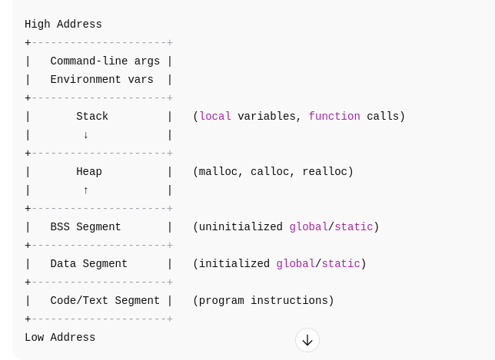
When is memory allocated in C?
- Compile Time (Static Allocation):
  - Memory for global and static variables is allocated when the program loads (before main() starts).
  - These live in the Data Segment (initialized) or BSS Segment (uninitialized).
- Runtime (Stack Allocation):
  - Memory for local variables and function parameters is allocated automatically on the stack each time a function is called.
  - When the function returns, this memory is freed automatically.
- Runtime (Heap Allocation):
  - Memory allocated dynamically using functions like malloc(), calloc(), realloc().
  - This memory remains allocated until the programmer explicitly frees it using free().

Storage Class / Variable Type | Where Stored? | When Allocated? | Lifetime | Example
Global Variables | Data Segment (initialized) / BSS (uninitialized) | Program load time (before main() starts) | Till program terminates | int g = 10;
Static Variables (local or global) | Data Segment (initialized) / BSS (uninitialized) | Program load time | Till program terminates | static int s = 5;
Automatic (auto) Variables | Stack | At runtime, when function is called | Till function returns | void f(){ int x=10; }
Dynamic Variables (malloc, calloc, realloc) | Heap | At runtime, when allocation function is called | Till free() is called | int *p = malloc(sizeof(int));

Code Segment (Text Segment)
What is it?
- The Code Segment (also called the Text Segment) is the part of a program's memory where the compiled executable instructions (machine code) are stored.
- It contains the actual program code that the CPU executes.
Key Features:
- Read-only: Prevents accidental modification of instructions during execution.
- Fixed size: Determined when the program is compiled.
- Shared: Can be shared between multiple running instances of the program to save memory.

Call by Value:
- In call by value, a copy of the actual argument’s value is passed to the function, so changes made inside the function do not affect the original variable.

- Call by Reference:
- In call by reference, the function receives the address of the actual argument, allowing the function to modify the original variable directly.
Why is a constant value unchangeable during program execution?
- Compiler Enforcement:
  - When you declare something as const in C, the compiler treats it as read-only.
  - It checks your code and prevents any instruction that tries to modify that value — so you get a compile-time error if you try to change it.
- Program Safety & Predictability:
  - Constants help make your program safer and more predictable.
  - If a value is meant to stay the same, marking it const ensures no accidental changes that could cause bugs.
- Memory Protection:
  - For global or static const variables and string literals, the compiler places them in read-only areas of memory (like the read-only data segment).
  - If the program tries to modify these, the operating system prevents it, causing a runtime error (segmentation fault).
- Optimization:
  - Knowing a value won’t change lets the compiler optimize your code better — e.g., replacing variables with literal values directly, improving speed and reducing memory usage.
printf() function
- Use: To display output on the screen (console).
- It prints formatted text and variables.
- Prototype:
int printf(const char *format, ...);

2. scanf() function
- Use: To read input from the user (console).
- It reads formatted input and stores values in variables.
- Prototype:
int scanf(const char *format, ...);
3. Format Specifiers
- Special placeholders inside printf() and scanf() that tell the function what type of data to print or read.
- They start with %.

Common Format Specifiers
Specifier | Data Type | Example
%d | int | printf("%d", 5); prints 5
%c | char | printf("%c", 'A'); prints A
%f | float | printf("%f", 3.14); prints 3.140000
%lf | double | printf("%lf", 3.1415); prints 3.141500
%s | string (char array) | printf("%s", "Hi"); prints Hi
%u | unsigned int | For unsigned integer
%x | Hexadecimal int | Prints integer in hex

printf("Name: %s, Age: %d\n", name, age);
return 0;
}
Return values of printf() and scanf()
1. printf() return value
- Returns the number of characters printed (excluding the null terminator).
- If an error occurs, it returns a negative value.

2. scanf() return value
- Returns the number of input items successfully matched and assigned.
- If the input doesn't match the format or EOF is encountered, it returns a smaller number or EOF (-1).
Why use & (address operator) in scanf() but not in printf()?
1. scanf() needs the address to store input
- scanf() reads input from the user and stores it in a variable.
- To do this, it needs to know where in memory to put the input value.
- So, you pass the address of the variable using & so scanf() can modify the variable’s value directly.
printf() just prints the value, no modification needed
- printf() only reads the value to display it.
- It doesn’t need to modify the variable, so you just pass the value itself, not its address.
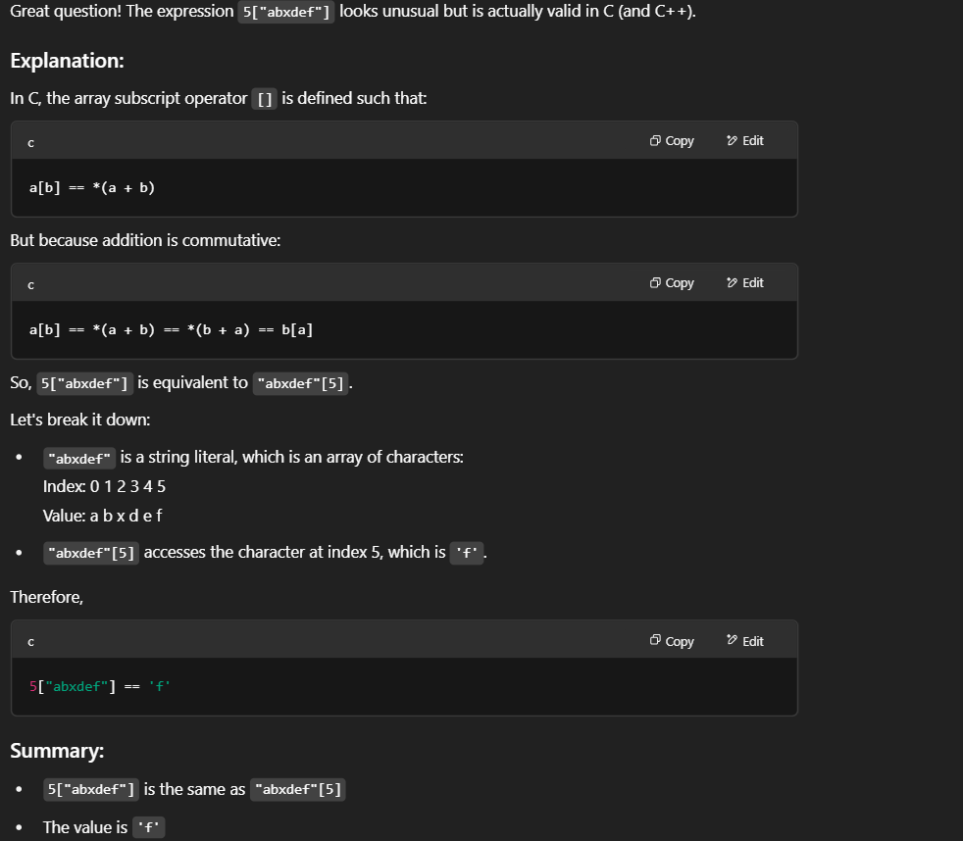

A built-in function in C refers to any function that is provided by the C standard library or the compiler itself, which you can directly use in your code without having to define it yourself.
Key points about built-in functions in C:
- Provided by the Standard Library:
These functions are declared in standard headers like <stdio.h>, <stdlib.h>, <math.h>, etc.
Examples: printf(), scanf(), malloc(), free(), strlen(), sqrt().
- Predefined and Ready to Use:
You don’t write their code; the compiler or linker handles them.
- Often Optimized:
Some compilers provide built-in versions of certain functions (like memcpy, memset, etc.) that are optimized for the target hardware.

getchar() and putchar() in C
These functions are used for character I/O (input/output) — that means they deal with one character at a time.

1. getchar()
- Purpose: Reads a single character from the standard input (keyboard).
- Prototype: int getchar(void);
- Returns: The ASCII value of the entered character.
putchar()
- Purpose: Writes (displays) a single character to the standard output (console).
- Prototype: int putchar(int char);
- Takes: A character (or its ASCII value) to display.
• Reading = Getting a value (from memory or user)
• Writing = Putting a value (into memory or output)

✅ What is a Buffer?
A buffer is a temporary storage area in RAM used to hold data during input or output operations.
- It helps match the speed difference between fast CPUs and slow I/O devices (keyboard, screen, etc.).
- scanf() and printf() both use buffers, but in different ways.
🖨️ printf() and Output Buffering
🔹 How it works:
- When you use printf(), the output is first stored in an output buffer.
- The content is only displayed when:
  - The buffer is full, or
  - You print a newline character \n, or
  - You manually flush it using fflush(stdout);
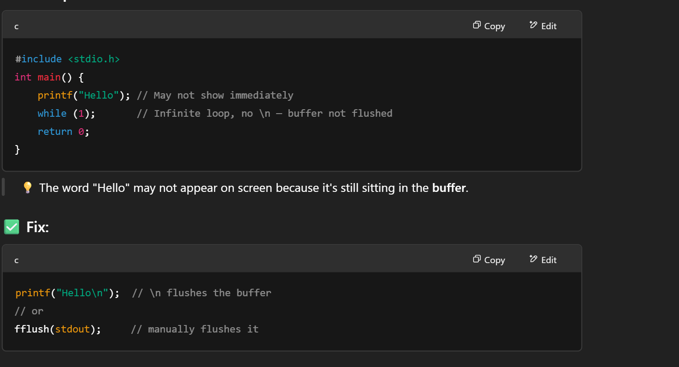

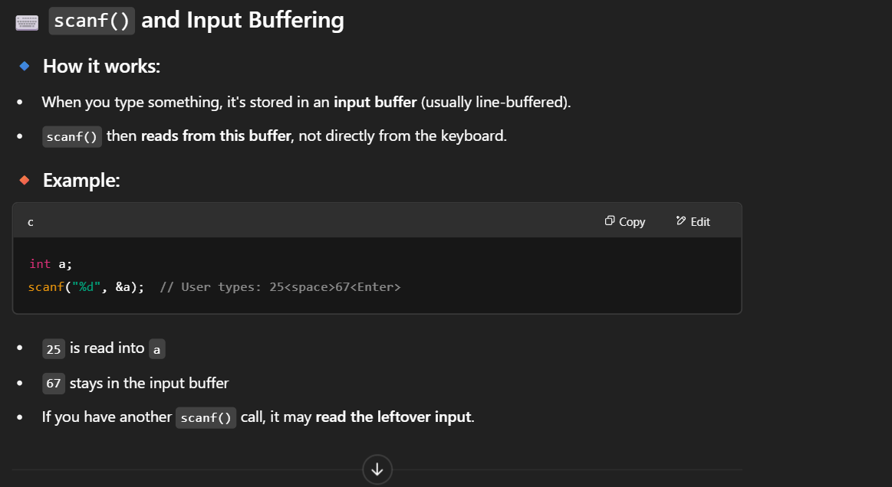
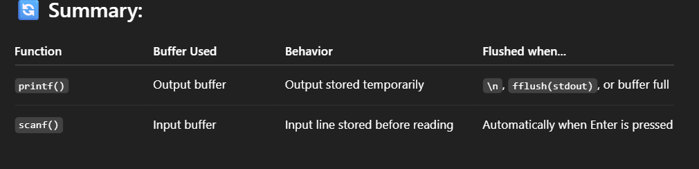
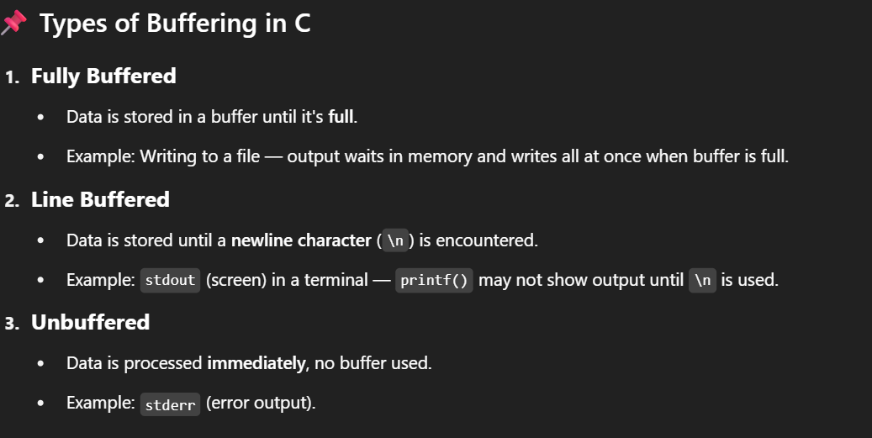

• compiler is a special program that translates C source code into machine code (binary code) that the computer can execute.
• It takes the entire program at once and converts it into an executable file like a.out or file.exe.
• During compilation, it checks for syntax errors, macro expansion, and code optimization.
• The compiler works in multiple stages: preprocessing, compilation, assembling, and linking.
• After successful compilation, the output is a fast-running program because it's already in machine language.
• Common C compilers include GCC, Turbo C, Clang, and MSVC.
1. Preprocessing
- In this stage, all the # directives like #include, #define, and macros are processed.
- Comments are removed, and header files are expanded into the source code.
- The output is a file with .i extension (e.g., file.i).
🧾 Example:
c
CopyEdit
#include <stdio.h>
#define PI 3.14
gets expanded to include the full contents of stdio.h, and PI is replaced by 3.14.

✅ 2. Compilation
- The preprocessed code is translated into assembly language.
- Syntax errors are detected at this stage.
- The output is a .s file (e.g., file.s) containing assembly code.

✅ 3. Assembling
- The assembly code is converted into machine code (binary) by an assembler.
- The output is an object file with .o extension (e.g., file.o).
- This file is not yet executable.

✅ 4. Linking
- The object file is linked with standard libraries (e.g., for printf, scanf) and other object files.
- It combines all code into a final executable file like a.out or file.exe.
C doesn't support function overloading because:
- It uses simple name-based linking without name mangling.
- It was designed to be minimal and efficient.
- It lacks features like type-based dispatch or templates.

Name Mangling in C++
- Definition:
Name mangling is the process by which the C++ compiler encodes additional information (like function parameters, namespaces, classes, etc.) into the function name when generating object code.
- Why needed?
In C++, you can have:
  - Function overloading (same function name, different parameter types).
  - Namespaces.
  - Classes with member functions.
If the compiler used the plain function name (like C does), it could not distinguish between overloaded functions.
Name mangling solves this by generating unique symbols for each function.

VOID POINTER: A void pointer is a generic pointer that can point to any data type. It is type-independent during assignment, but must be typecast to the correct type before dereferencing, because the compiler does not know how many bytes to access.
Ex:
int a = 10;
void *ptr = &a;
printf("%d\n", *(int *)ptr); // typecasting is necessary

What is a Dangling Pointer in C?
A dangling pointer is a pointer that continues to point to a memory location that has been freed or deallocated. Accessing such memory is undefined behavior and may cause crashes or bugs.
After free()
Returning address of local variable
Using a pointer after the scope ends
- After freeing, always set the pointer to NULL:
free(ptr);
ptr = NULL; // avoids accidental use
- it's better to return the address of a static variable instead of a local variable because static variables persist for the entire program lifetime, whereas local variables are destroyed when the function returns.

What is a NULL Pointer?
- A NULL pointer is a pointer that does not point to any valid memory location.
- It is typically used to indicate that a pointer is not initialized or is intentionally empty.
Syntax:int *ptr = NULL;
Why use a NULL pointer?
- To avoid dangling pointers
- To check whether a pointer is safe to dereference
- To initialize pointers when no memory has been allocated yet
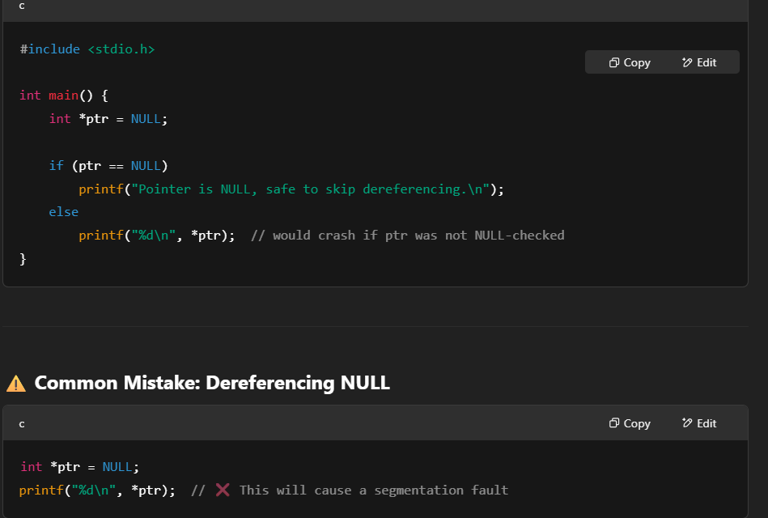

What is Memory Leak in C?
A memory leak occurs when a program allocates memory dynamically (using malloc(), calloc(), etc.) but fails to deallocate it using free(). As a result, the memory remains unusable (lost) until the program ends.

✅ Why is it bad?
- The allocated memory is not used and also not returned to the system.
- Over time, memory leaks reduce available memory, causing performance issues or program crashes, especially in long-running applications.

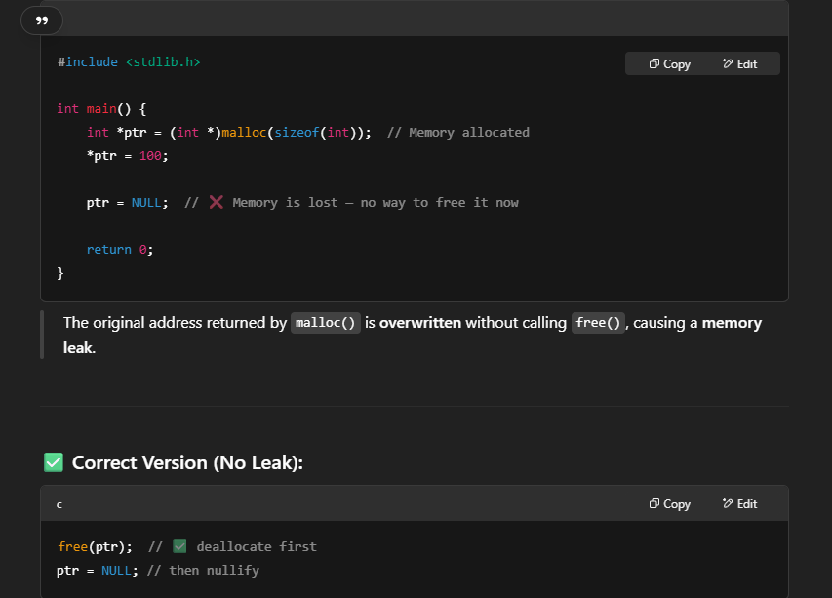

A wild pointer is a pointer that has not been initialized to any valid memory location but is used anyway. It points to some random or garbage address, causing unpredictable behavior or program crashes.
✅ Why do wild pointers happen?
- Declaring a pointer without initializing it.
- Using pointers after they have been freed (dangling pointers can also be wild if used incorrectly).
- Using uninitialized pointers in general.
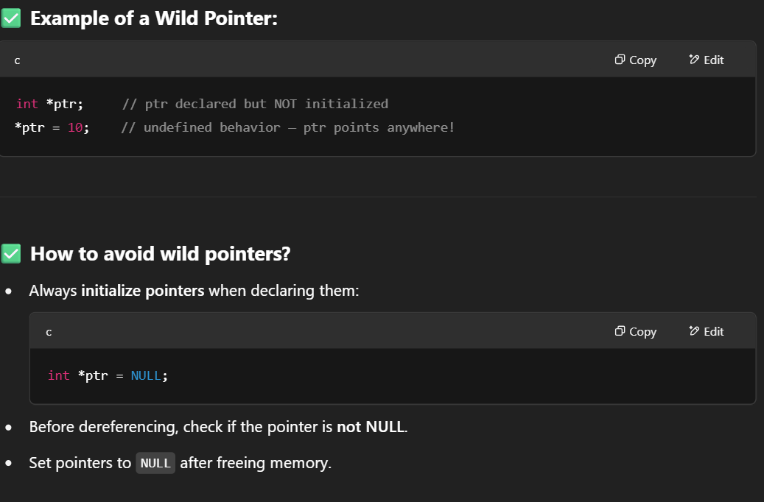

What is a Segmentation Fault?
A Segmentation Fault (segfault) is a runtime error that occurs when a program tries to access a memory location that it is not allowed to access.
✅ Why does it happen?
- Dereferencing NULL or uninitialized pointers (wild pointers)
- Accessing memory beyond array bounds
- Writing to read-only memory
- Using dangling pointers (accessing freed memory)
- Violating memory protection rules of the operating system
How to avoid segmentation faults?
- Always initialize pointers.
- Check pointers before dereferencing.
- Avoid out-of-bound array access.
- Use tools like Valgrind or AddressSanitizer for debugging.

What is a Function Pointer?
A function pointer is a pointer that stores the address of a function instead of data.
✅ Why use Function Pointers?
- To call functions dynamically at runtime.
- To implement callback functions.
- To create flexible and reusable code, such as in event-driven programs.
✅ How to declare a Function Pointer?
If a function has the prototype
int add(int, int);
Then the function pointer declaration is:
int (*funcPtr)(int, int);

✅ How to use it?
Assign the function address:
funcPtr = &add;
Call the function via pointer:
int result = funcPtr(5, 3);

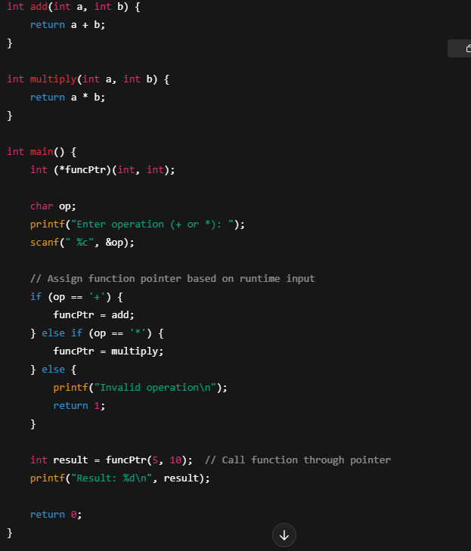
What is a Callback Function?
A callback function is a function that is passed as an argument to another function and is called inside that function to perform a specific task.
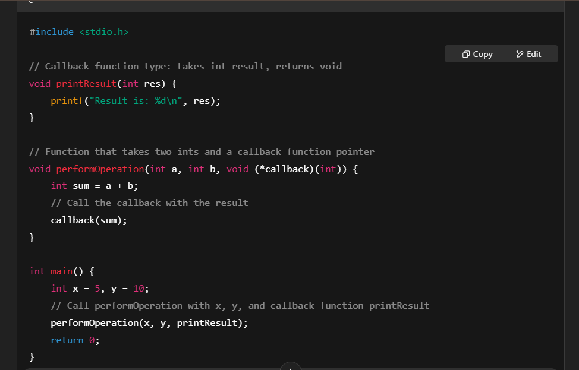
In programming, both if-else and switch statements are used for conditional branching, but they differ in how they handle multiple conditions and what they can test.
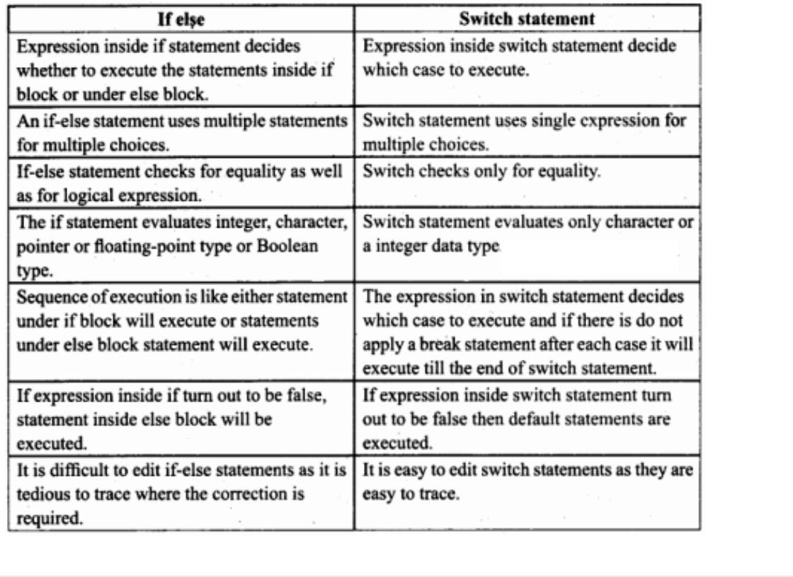

Difference between for and while in sentence form:
- A for loop is generally used when the number of iterations is known in advance, while a while loop is preferred when the number of iterations is not known and depends on a condition evaluated at runtime.
- In a for loop, the initialization, condition, and update statements are all written in a single line, making it more compact and readable for counter-controlled loops.
- A while loop only includes the condition in its syntax, and the initialization and update must be written separately, which provides more flexibility but can be less concise.
- A for loop is ideal when you are working with a fixed range, such as iterating from 1 to 10, whereas a while loop is better when you're waiting for a condition to become false, like reading input until the user types "exit".
A while loop checks the condition before executing the loop body, so if the condition is false initially, the loop body may not execute even once.
• A do-while loop checks the condition after executing the loop body, so the loop body executes at least once, even if the condition is false from the beginning.
• In a while loop, the structure is:
- “Check first, then run”
- So it is used when you are not sure whether the loop should run even once.
• In a do-while loop, the structure is:
- “Run first, then check”
- So it is useful when you want to guarantee one execution before checking the condition (like prompting user input at least once).
• Both loops are used for repeating tasks based on a condition, but the main difference lies in the position of the condition check—before in while, and after in do-while.

Common Applications of Recursion:
- 🔁 Mathematical Problems
  - Factorial calculation: n! = n × (n-1)!
  - Fibonacci sequence: F(n) = F(n-1) + F(n-2)
  - Power calculation: a^b = a × a^(b-1)
  - Greatest Common Divisor (GCD) using Euclid’s algorithm
- 🌳 Data Structures (Tree and Graph Traversals)
  - Binary Tree Traversals: Inorder, Preorder, Postorder
  - Depth-First Search (DFS) in graphs
  - Expression tree evaluation
- 🧮 Divide and Conquer Algorithms
  - Merge Sort
  - Quick Sort
  - Binary Search
- • A loop uses repetition statements like for, while, or do-while to execute a block of code multiple times, while recursion is a process where a function calls itself to solve a problem.
- • In a loop, the control flow is managed using iteration constructs, but in recursion, the control flow is managed using function calls and the call stack.
- • A loop runs until a condition becomes false, whereas recursion continues until a base condition is met.
- • Loops are generally more memory-efficient, since they don’t use extra stack space, while recursion can consume more memory because each recursive call is stored in the function call stack.
- • Recursion makes code simpler and more readable for problems like tree traversal or factorials, but loops are usually more efficient for repetitive tasks like printing numbers or summing arrays.
- • Infinite loops can occur if the loop condition is never false, and infinite recursion happens when there is no proper base case in the recursive function.
- • Loops are preferred for performance, while recursion is preferred for solving problems with recursive patterns or hierarchical structures.

🔹 1. Loops

✅ Advantages of Loops
- Efficient in memory → Loops don’t need extra stack space; they just repeat instructions.
- Faster execution → No overhead of function calls (pushing/popping frames).
- Good for iterative tasks → Ideal for problems like traversing arrays, counting, or repeated operations.
- Easier debugging → You can step through loop iterations easily in a debugger.
- No risk of stack overflow → Unlike recursion, loops don’t consume stack frames.
- Predictable performance → Loops generally run in constant space (O(1)).

❌ Disadvantages of Loops
- Code readability → For problems like tree traversal or factorial, loops may look messy compared to recursion.
- Not elegant for divide-and-conquer → Problems like quicksort, DFS, Fibonacci are harder to express using loops.
- Complex nested loops → Multiple loops make code harder to maintain.
- Requires manual stack → Some problems (like backtracking) need you to implement your own stack when using loops.
- Harder to map to mathematical definitions → Loops sometimes obscure the mathematical beauty of a recursive definition.

🔹 2. Recursion

✅ Advantages of Recursion
- Code simplicity & elegance → Many problems (factorial, Fibonacci, tree traversal, DFS, backtracking) look cleaner.
- Natural fit for divide-and-conquer → Quicksort, Mergesort, Binary Search, etc. map directly to recursion.
- Readable mapping to mathematical formulas → Recursive code mirrors the math definition (e.g., factorial n! = n * (n-1)!).
- Useful in data structures → Recursion makes it easy to implement algorithms on trees, graphs, linked lists.
- Reduces boilerplate code → Some recursive solutions are shorter and avoid explicit stack/queue implementation.

❌ Disadvantages of Recursion
- High memory usage → Each recursive call uses a new stack frame → O(n) extra space.
- Slower execution → Overhead of function calls (push/pop, return address management).
- Stack overflow risk → Deep recursion (e.g., Fibonacci(100000)) will crash due to limited stack size.
- Harder to debug → Tracking multiple recursive calls in a debugger is tricky.
- Not always intuitive for beginners → Thinking in recursion requires a different mindset.
- May be inefficient without optimization → Some recursive problems (like naive Fibonacci) redo work unless memoization is added.

🔹 3. When to Use What
- Use Loops → When performance and memory efficiency matter (iterating arrays, counting, numeric computations).
- Use Recursion → When problem is naturally recursive (trees, graphs, divide-and-conquer, backtracking).

✅ Interview-Style Summary:
- Loops are memory-efficient, fast, and simple for repetitive tasks, but can be less elegant for recursive problems.
- Recursion produces clean and intuitive code for problems that are naturally hierarchical (trees, backtracking, divide-and-conquer), but comes with overhead, memory usage, and risk of stack overflow.

External Storage Class in C – Brief Explanation
The extern storage class in C is used to declare a global variable or function that is defined in another file or location.

🔹 Key Points:
- extern tells the compiler that the variable or function exists, but its memory is allocated elsewhere.
- It is mainly used to share variables or functions between multiple C files.
- The default storage location for extern is the global scope, and it has static storage duration (exists throughout program execution).
- You cannot initialize a variable when using extern in a declaration.

1. Static Local Variables
- When a variable is declared as static inside a function, it retains its value between function calls.
- Unlike normal local variables, it is initialized only once, and memory is not reallocated on every call.
Example:
void counter() {
static int count = 0; // value persists between calls
count++;
printf("%d\n", count);
}

int main() {
counter(); // prints 1
counter(); // prints 2
counter(); // prints 3
}

🔹 2. Static Global Variables
- When a global variable is declared as static, it becomes private to the file in which it is declared.
- This means it cannot be accessed from other files, even if you use extern.
Example (in file1.c):
static int num = 10; // only accessible in file1.c
You cannot use extern int num; in another file to access this variable.

🔹 3. Static Functions
- When a function is declared as static, it is limited to the file in which it is defined.
- This helps encapsulate internal logic and avoid name clashes in multi-file projects.
static void helper() {
// only visible in this file
}
CONSTANT:
• Yes, you can change constant data using pointer tricks.
• But it’s not safe, not portable, and not recommended.
• Only do it in very controlled low-level scenarios (e.g., embedded systems, hardware registers

1. const int *ptr; → Pointer to Constant Data
- Meaning: You cannot change the value being pointed to.
- But you can change the pointer to point somewhere else.
c
CopyEdit
const int x = 10, y = 20;
const int *ptr = &x; // valid

*ptr = 100; // ❌ Error: cannot modify *ptr
ptr = &y; // ✅ OK: ptr can point elsewhere
📌 Use Case: When you want read-only access to data through a pointer.

✅ 2. int *const ptr; → Constant Pointer to Data
- Meaning: You can change the data being pointed to.
- But you cannot change the pointer itself.
int x = 10, y = 20;
int *const ptr = &x; // must initialize

*ptr = 50; // ✅ OK: value can be changed
ptr = &y; // ❌ Error: cannot change address
📌 Use Case: When the pointer should always point to the same location, but the data can be modified.

✅ 3. const int *const ptr; → Constant Pointer to Constant Data
- Meaning: You cannot change the data or the pointer.
98,m.const int x = 10;
const int *const ptr = &x;

*ptr = 20; // ❌ Error: can't modify value
ptr = NULL; // ❌ Error: can't change pointer
📌 Use Case: When you want full protection — neither the data nor the pointer should be changed.

Arrays of Structures
- Store and process multiple records (like a list of students, employees, etc.).
3. Linked Lists / Trees / Graphs
- Use self-referential structures to implement dynamic data structures.
A self-referential structure is a structure that includes a pointer to a variable of the same type within it. It allows implementation of dynamic data structures like linked lists and trees. The self-reference must always be through a pointer, otherwise it would create infinite recursive memory requirements.
4. Function Arguments
- Pass multiple related values using a single structure instead of many parameters.
5. File Handling
- Used to read/write structured binary data to files.
6. Modular Programming
- Used to organize complex data and create custom data types for maintainable code.
- Structure padding is the extra unused memory added by the compiler to align data members of a structure in memory for performance reasons.

- ✅ Why is Padding Needed?
- Modern processors access memory faster if data is aligned to specific byte boundaries (like 4 or 8 bytes).
To maintain this alignment, the compiler may insert padding bytes between members of a structure.
an enumeration (or enum) is a user defined data type that contains a set of named integer constants. It is used to assign meaningful names to integer values, which makes a program easy to read and maintain.

